Ex. No. : 03 Date: 23/02/2026
Register No.: 231701030 Name: V.J.LAKSHNAN

Wire framing and Prototyping with Figma

Aim
To design and develop low-fidelity wireframes and interactive prototypes using Figma, in order to visualize user interface structure, user flow, and overall application design before final development.

Procedure:
The app is a smart digital platform for eco-cultural tourism in Jharkhand, featuring a web app frontend with chatbot, AR/VR previews, AI assistance, and marketplace. Here's a short procedure outlining the core tourist UI flow based on the prototype description.​
Tourist UI Flow
- Launch the web app or chatbot to explore destinations with AR/VR previews on Meta Quest hardware, viewing key activities, local delicacies, dos/don'ts, timings, taxi fares, and directions.​
- Interact with multilingual AI chatbot for personalized itinerary planning, nearby essentials, and support based on preferences and duration.​
- Access visa assist feature, which guides through e-Tourist Visa application and redirects to the official portal.​
- Browse marketplace for homestays, handicrafts, events, ecotourism packages; hire verified guides with blockchain certification, handle bookings/payments via Razorpay.​
- Submit feedback/reviews post-tour, with sentiment analysis stored in MongoDB backend.​
This flow supports safe, immersive travel via FastAPI backend and Unity for AR/VR.

Output
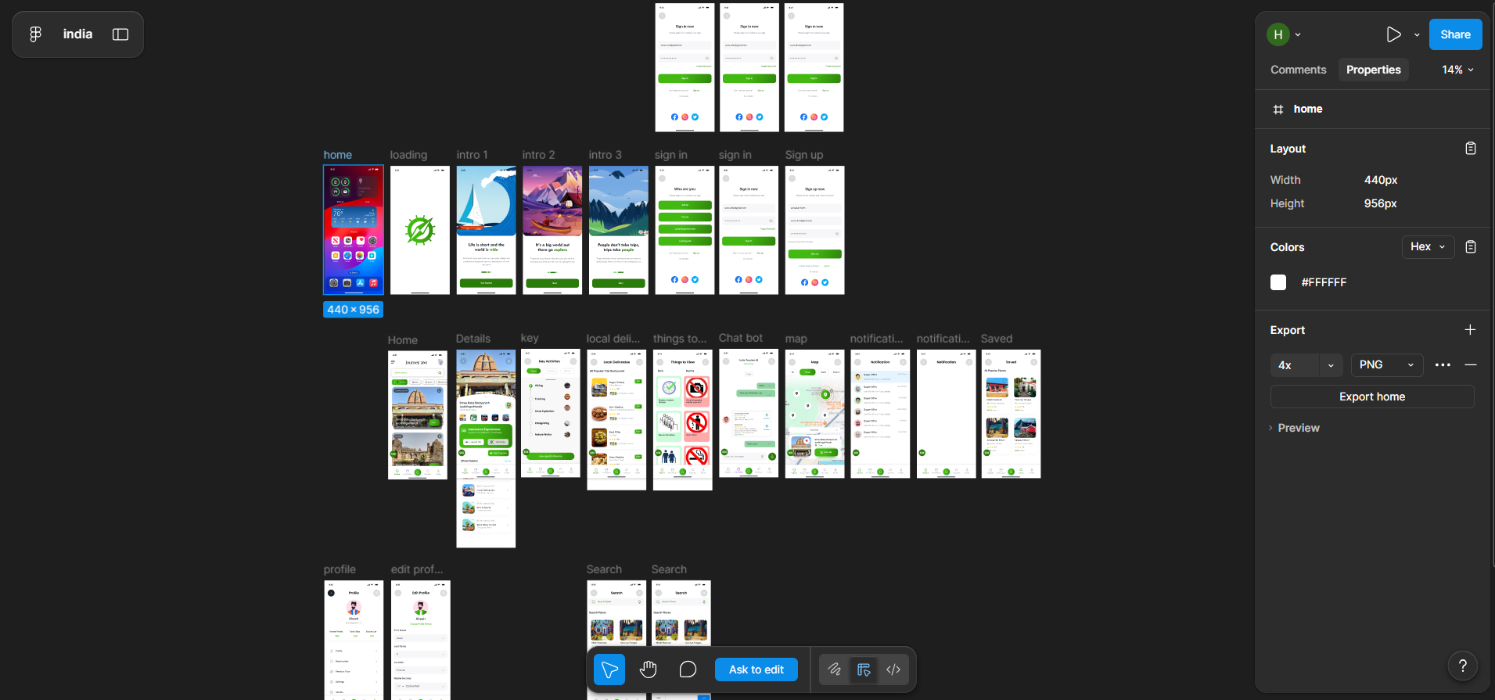

Result:
Hence the experiment is completed and the output is verified.

